Project Design Phase-II

Data Flow Diagram & User Stories

|  |  |
| --- | --- |
| Date | 24 October 2022 |
| Team ID |  |
| Project Name | Project - xxx |
| Maximum Marks | 4 Marks |

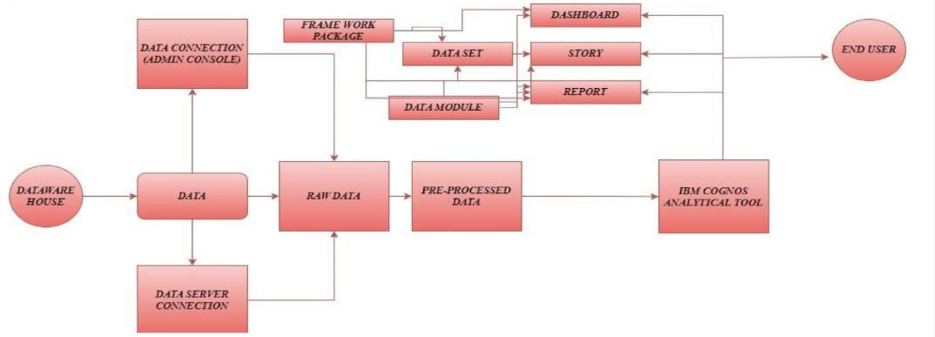

**User Stories**

|  |  |  |  |  |  |  |
| --- | --- | --- | --- | --- | --- | --- |
| **User Type** | **Functional**  **Requirement (Epic)** | **User Story Number** | **User Story / Task** | **Acceptance criteria** | **Priority** | **Release** |
| Patient | Hospitalization | USN-1 | Patients are required to hospitalize if they have any medical issues. | Direct Hospitalization | High | Sprint-1 |
|  | Treatment Report | USN-2 | Patients should collect them treatment report  and get further doctor consult. | They can receive the  report from hospital. | High | Sprint-1 |
| Hospital Management | Resource Allocation | USN-3 | Hospital Management should allocate the Necessary resource for treating the Patients. | Should be ready for any Circumstance. | High | Sprint-2 |
|  | Predicting Length of Stay | USN-4 | The Doctors should be aware of condition of Patients to predict the LoS. | Exploring the data about the patient health condition and predicting LoS. | High | Sprint-1 |
|  | Resource Availability | USN-5 | The Hospital Staff should be aware of available resources in hospital. | Visualizing the about the resource availability | High | Sprint-1 |